**Speech Emotion Recognition using Deep Learning Algorithms**

Dr. T. SampathKumar 1, a) Anugam Saikiran2, b) Irukulla Apoorva 3, c)

Gaddam Huldah grace4, d) Meghana Daddanala 5, e) Anugam Udaykiran6, f)

Author Affiliations

1 SR University, Warangal, India 2 SR Engineering College ,Warangal, India

3 SR Engineering College, Warangal, India 4 SR Engineering College, Warangal, India

5 SR Engineering College, Warangal, India 6 SR University ,Warangal, India

Author Emails

*a)* [*t.sampathkumar@sru.edu.in*](mailto:t.sampathkumar@sru.edu.in) *b)* [*saikirananugam@gmail.com*](mailto:saikirananugam@gmail.com) *c)* [*irukullaapoorva@gmail.com*](mailto:irukullaapoorva@gmail.com)

*d)* [*huldahgraceg@gmail.com*](mailto:huldahgraceg@gmail.com) *e)* [*meghanadaddanala@gmail.com*](mailto:meghanadaddanala@gmail.com) *f)anguamudaykiran@gmail.com*

**Abstract.** Speech emotion recognition is an act of recognizing human emotions and pitch. The primary objective of this is to automatically detect, classify, and interpret emotions from spoken language, enabling machines to comprehend and respond appropriately to human emotions. With the advent of deep learning algorithms and the availability of large annotated speech datasets, significant advancements have been made in SER, leading to its diverse applications across various domains. we can use some audio samples with this technique to anticipate emotions like sadness, rage, surprise, calmness, fear, neutrality, regret, and many others. It emphasizes the significance of SER in enabling machines to respond empathetically and adaptively to human emotions, ultimately enhancing user experience and interaction.

# INTRODUCTION

Speech is a powerful means of human communication. The ability to recognize and understand emotions from speech signals[8,9,13,15,16]has gained significant attention. Emotions play a crucial role in human interactions, influencing our perceptions, decisions, and behaviours. As the field of artificial intelligence strives to create more natural and human-like interactions between humans and machines, the need to imbue machines with the ability to perceive and respond to emotions becomes paramount. SER, powered by deep learning algorithms, provides a promising avenue to achieve this goal.

The impact of deep learning-based SER extends to various domains, including affective computing, virtual assistants, human-robot interaction, and mental health monitoring. By enabling machines to recognize and respond to human emotions, we can create more empathetic and adaptive systems that enhance user experience and foster meaningful interactions.

Deep learning, with its ability to automatically learn and extract high-level representations from raw data, has revolutionized the field of SER, leading to significant advancements in accuracy and robustness. Deep learning models, such as Convolutional Neural Networks (CNNs) [7,8,9,10,13], Multi-Layer Perceptron classifier (MLPC) [18,19,20], and their variants like Long Short-Term Memory (LSTM) [7,9,10,11] have shown remarkable capabilities in capturing complex patterns and temporal dependencies [14,16] present in speech data. These models have the potential to effectively capture the dynamic nature of emotions expressed through speech. This paper also discusses the pre-processing techniques for feature extraction from speech signals using masking noise and using librosa, noise reduce libraries.

Identifying the emotions that the speaker elicits while speaking is the article's goal. These days, detecting emotions has become a crucial responsibility. Speaking from a position of the low pitch [11] has a narrower range of pitch; conversely, speaking from a place of fear, fury, or excitement has a higher range of pitch. Speech recognition is helpful in facilitating human-machine communication. To recognise the emotions in this situation, many categorization algorithms are being used. The audio features MFCC[14,19,20], MEL [18], and chroma were utilised, as well as multi-layer perception[17]. These emotional recognition models have been taught to distinguish between calm, neutral, surprise, happy, sad, furious, afraid, and disgust. We will create a model with an MLP Classifier [14] and LSTM using the library sound file. This system will be able to identify emotions in audio files.

# RELATED WORK

In [1] The proposed system provides a comprehensive overview of speech emotion recognition techniques over the past two decades, including both traditional and deep learning approaches. Deep learning models mentioned in the paper include Convolutional Neural Networks (CNNs), Recurrent Neural Networks (RNNs), and their variations, such as Long Short-Term Memory (LSTM) and Gated Recurrent Units (GRUs). The authors discuss benchmark datasets, evaluation metrics, and challenges in the field, highlighting ongoing trends and future directions.

In [2] The suggested system mainly focuses on speech emotion recognition techniques, covering both traditional algorithms and deep learning methods. Deep learning models discussed in the paper include CNNs, RNNs (LSTM, GRU), hybrid models (such as Convolutional Recurrent Neural Networks - CRNNs), and attention mechanisms. It provides insights into feature extraction, feature selection, and classification models employed in SER. The authors also discuss the challenges and future trends, including multimodal emotion recognition and explainable AI in SER.

In [3] The major emphasis of the proposed system is to focus specifically on deep learning techniques for speech emotion recognition. It covers various deep learning architectures, including CNNs, RNNs, LSTM, and GRUs, and discusses their applications in SER. The authors provide a comprehensive analysis of feature extraction, preprocessing techniques, and datasets used in deep learning-based SER. They also highlight the challenges and future directions in the field.

In [4]  The proposed framework introduces a multitask learning framework for speech emotion recognition that incorporates residual fusion and hierarchical attention mechanisms. The approach leverages the shared information between emotion recognition and auxiliary tasks to improve the overall performance. The experimental evaluation shows promising results and contributes to the advancement of SER using deep learning techniques.

In [5] The review provides insights into the strengths and limitations of each model, discusses the impact of different architectures and training strategies, and highlights the challenges and future directions in the field of speech emotion recognition using deep learning. It serves as a valuable resource for researchers and practitioners interested in understanding the state-of-the-art techniques and advancements in SER.

In [6] This paper the proposed model introduces his comprehensive review paper explores the application of deep learning techniques for speech emotion recognition. It covers a range of deep learning models, including CNNs, RNNs (LSTM, GRU), attention-based models, and hybrid architectures, discussing their effectiveness and advancements in the field.

# PROPOSED METHODOLOGY

## Flow Chart

Audio Input: The first step in the flowchart is the audio input, which can be acquired via a microphone or an audio file.

Preprocessing: The audio input is then cleaned up to remove any obtrusive noise or artifacts that can compromise the model's accuracy. The audio signal may be subject to filtering, normalization, or resampling in this process.

The preprocessed audio stream is next processed to extract pertinent acoustic properties including pitch, intensity, and spectral content. These attributes are subsequently transformed into a numerical representation appropriate for examination by the machine learning algorithm. The diagram shown in Fig. 1 depicts the flowchart.

The retrieved characteristics are then chosen depending on their applicability to the job of emotion recognition. This can entail methods like principal component analysis or feature ranking algorithms.

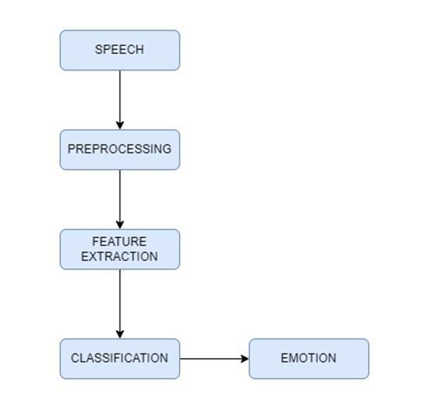

Fig. 1. Block diagram of the proposed system.

The chosen characteristics are then used in an emotion classification algorithm that has been trained on a labelled dataset [11,16] of speech samples with well-known emotional states. This training data is used by the algorithm to categories the input voice sample's emotional state as one of many potential emotions, such as joyful, sad, angry, or neutral.

The output, which shows the anticipated emotional state [8,13] of the input speech sample, is the last step in the flowchart. The results may be seen.

## UML Diagrams

1. Sequence Diagram

The interactions between items or components in a system over time are depicted in a sequence diagram, a form of UML (Unified Modelling Language) diagram. The sequence in which these interactions take place as well as the flow of messages or events between various objects or components are shown in Fig.2.

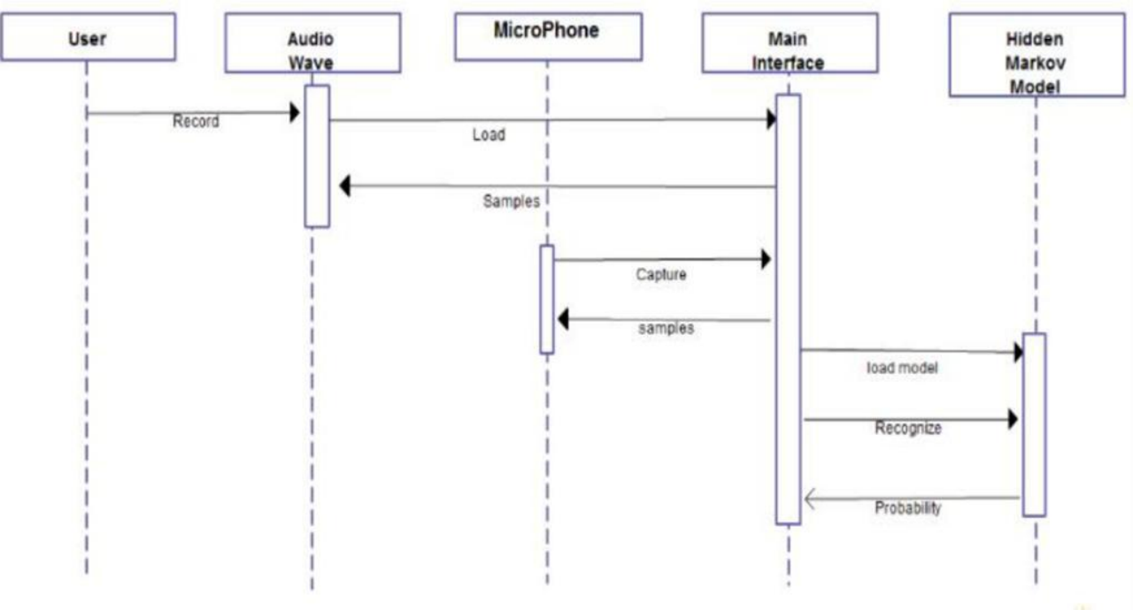

Fig. 2 Sequence diagram.

2. Use Case Diagram

A use case diagram is a form of UML (Unified Modelling Language) diagram that illustrates the actors, use cases, and connections between them that make up a system's functionality. The interaction between the system and the user is shown in Fig.3.

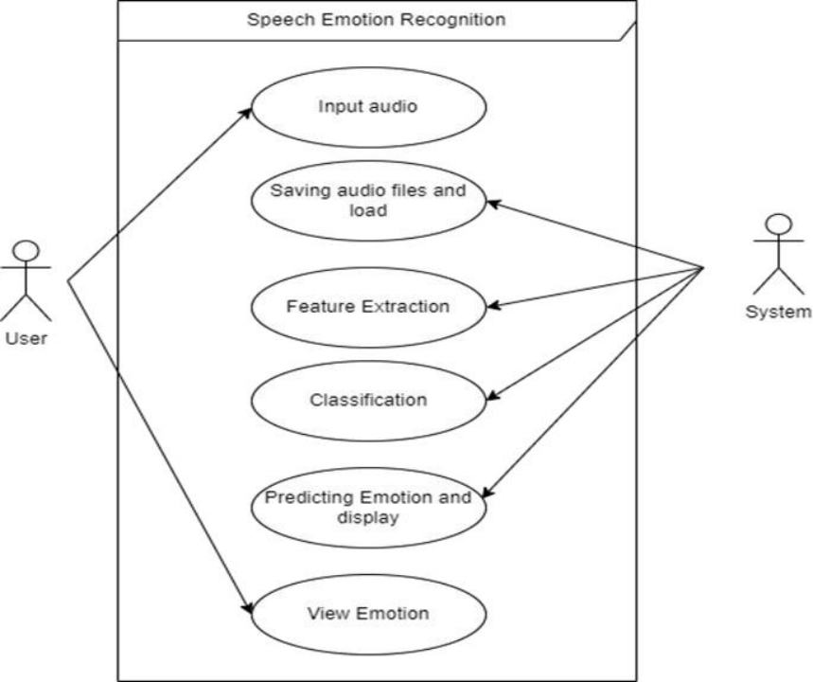

Fig. 3 Use case Diagram.

## Dataset

The Ravdness dataset is downloaded from Kaggle. There are 7356 files totaling 24.8 GB in the Ryerson Audio-Visual Database of Emotional Speech and Song (RAVDESS). The database comprises 24 professional actors (12 females and 12 males), each of whom reads two lexically related phrases with a neutral North American accent. Both music and speech contain calm, joyful, sad, angry, terrified, surprise, and disgust expressions. Each expression is created at two emotional intensity levels (normal, strong), plus a third neutral expression. Three modality forms are accessible for all conditions: Audio-only (16bit, 48kHz.wav), Audio-Video (720p H.264, AAC 48kHz,.mp4), and Video-only (without sound).

An example of the naming convention of the filename is 02-01-06-01-02-01-12.mp4

The file's modality [12] is represented by the first two digits; 01 denotes that it is a full-AV type file, 02 that it is only a video file, and 03 that it is only an audio file. In the above-given example, 02 specifies that it is a video file.

The voice channel is represented by the next two numbers. 01 denotes speech, and 02 denotes song. Here 01 suggests that it is of type speech.

The fifth and sixth digits in an audio file are used to reflect a person's emotional state. 01 stands for neutral, 02 for calm, 03 for happiness, 04 for sadness, 05 for anger, 06 for fear, 07 for disgust, and 08 for surprise. Here 06 explains that the emotion of the speech is fearful.

In an audio file, the seventh and eighth numbers signify the level of emotion. Strong is denoted by 02, whereas 01 stands for average intensity. No high intensity can be found in neutral feelings. Here 01 represents that the level of intensity is normal.

The statements are represented by the ninth and tenth digits. 01 is a representation of the phrase "Kids are talking by the door." Additionally, 02 stands for the phrase "Dogs are sitting by the door.". Here 02 represents statement 2.

The recurrence is shown by the eleventh and twelfth digits. The first repeat is represented by 01 in this sentence. The second repeat is represented by 02 in the sentence. Here 01 represents that the statement is repeated only once.

The Actor is represented by the final two numbers. The collection contains 24 actor files. Odd numbers are used to symbolize male performers, whereas even numbers are used to represent female actresses. Here, the number 12 stands for an actress, who is a female.

## Data Preprocessing

Collecting data in the real world comes with its own set of issues. It is frequently exceedingly disorganized and contains missing data, outliers, an unstructured approach, etc. We must initially undertake preprocessing operations that only allow us to use the data for further observation and training our machine learning model, not for seeking for any insights into the data. Before submitting our data to the machine learning model, we do data processing using missing values treatment, outliers’ identification, normalization, and data split. To clean the voice, we utilized the librosa and noise reduction packages.

Cleaning is done by down sampling audio files, applying a mask, and then directing it to a clean folder. The mask is used to eliminate extraneous empty voices surrounding the main audio voice.

Steps for Data Preprocessing:

Masking aims to remove unnecessary empty voices surrounding the main audio voice by applying a mask. This involves down-sampling the audio files and applying the mask based on a threshold value. We consider the sampling rate and threshold values as parameters for removing empty and unnecessary voices.

An empty list called a mask is initialized. This list will store Boolean values indicating whether each sample in the audio data should be kept (True) or discarded (False) based on the calculated mask. Next, absolute values are calculated by converting the audio file using the Pandas series function. This considers both positive and negative amplitudes and captures the overall magnitude of the audio signals.

Next, the rolling mean of the absolute values is calculated using the rolling function from the panda’s library. This mean is computed over a window of size int(rate/10) with a minimum of 1 period. The center parameter is set to True, ensuring that the calculated mean corresponds to the sample at the center of the window.

Subsequently, a loop iterates over each mean value in y_mean. For each mean value, if it exceeds the threshold, it suggests the presence of the main audio voice, so True is appended to the mask list. Otherwise, if the mean value is below the threshold, False is appended to the mask list.

After the loop has processed all the mean values, the function returns the resulting mask list.

The generated mask can be utilized as a filter to remove unnecessary empty voices or noise surrounding the main audio voice. By applying the mask to the audio data, the code effectively retains the relevant portions of the audio while discarding the unwanted segments, thus facilitating the cleaning process.

## Feature Extraction

Feature extraction plays a crucial role in speech emotion recognition, as it involves transforming raw speech signals into representative features that capture relevant information for emotion classification [10,20]. In this context, three commonly used features for speech emotion recognition are MFCC (Mel-frequency cepstral coefficients), chroma, and mel spectrogram.

1. MFCC (Mel-frequency cepstral coefficients):

MFCCs are widely used in speech processing and provide a compact representation of the spectral envelope of an audio signal. The MFCC extraction process involves several steps, including framing the audio signal into small segments, applying the Fourier Transform to obtain the power spectrum, mapping the spectrum onto the mel scale to approximate human auditory perception, and finally computing the discrete cosine transform to obtain the cepstral coefficients. MFCCs capture the spectral shape of the speech signal and are effective in capturing phonetic and acoustic information.

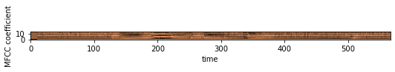

Fig.4 MFCC features.

The plot generated in the Fig.4 shows the MFCC features of the audio file, where the x-axis represents time and the y-axis represents MFCC coefficients.

2. Chroma:

Chroma features represent the distribution of pitch classes or musical notes within an audio signal. They are derived by calculating the magnitude of the short-term Fourier Transform (STFT) and mapping the resulting spectrum onto a 12-dimensional chroma vector corresponding to the 12 musical notes. Chroma features are particularly useful for capturing tonal and harmonic information in speech signals, making them relevant for speech emotion recognition. They can reveal the presence of musical or melodic patterns in the speech, which can be indicative of certain emotional states.

3. Mel Spectrogram:

The mel spectrogram is a visual representation of the power spectral density of an audio signal in the mel-frequency domain. It is obtained by dividing the frequency spectrum into mel-scale bins, where each bin represents a specific range of frequencies. The mel spectrogram highlights the energy distribution across different frequency bands and provides insights into the spectral characteristics of the speech signal. By averaging the mel spectrogram over time, we can obtain a compact representation of the speech signal's spectral content, which can be relevant for capturing emotional cues.

In speech emotion recognition, these features are computed from the speech signal using libraries like `librosa` or `python_speech_features`. Once the features are extracted, they can be used as input to machine learning algorithms for training emotion classification models. These models learn to associate specific patterns in the extracted features with different emotional states, enabling the recognition and classification of emotions in speech.

The subplot in the Fig.5 displays the waveform, MFCC, and mel spectrogram of the first four audio files. Understanding the temporal and spectral properties of the audio files with the assistance of this visualisation makes it easier to do further analysis and feature extraction for tasks like speech recognition or emotion categorization.

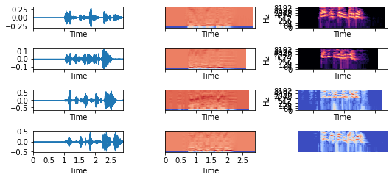

Fig.5 waveform, MFCC, and mel spectogram

The sound file is opened using soundfile. SoundFile and the audio data is read into the X array, while the sample rate is stored in sample rate.

If the chroma parameter is set to True, the Short-Time Fourier Transform (STFT) is calculated by taking the absolute value of the STFT of X using librosa.stft.

A result array is initialized as an empty numpy array. If the mfcc parameter is True, the MFCC features are computed using librosa.feature.mfcc, with X as the audio data, sample_rate as the sample rate, and n_mfcc set to 40. The resulting MFCCs are then averaged across time (axis=0) and concatenated to the result array.

Similarly, if the chroma parameter is True, the chroma feature is calculated using librosa.feature.chroma_stft on the STFT array stft, and the resulting chroma features are averaged across time and appended to the result array.

Finally, if the mel parameter is True, the mel spectrogram is computed using librosa.feature.melspectrogram on the audio data X, with sample_rate as the sample rate. The mel spectrogram is averaged across time and concatenated to the result array.

By combining these three features (MFCC, chroma, and mel spectrogram), speech emotion recognition systems can capture a wide range of acoustic characteristics relevant to emotion expression in speech. These features provide valuable information about the spectral shape, tonal patterns, and energy distribution in the speech signal, enabling effective emotion classification and analysis.

## Models used

1. Multi-Layer Perceptron Classifier (MLPC)

For supervised learning tasks like classification and regression, the Multilayer Perceptron Classifier (MLPC) is a kind of artificial neural network. In MLPC, the data is transmitted through a number of layers containing neurons or units, and each unit applies a straightforward mathematical operation to the incoming data. Up until the final output is generated, each layer's output is passed on to the following layer. This enables MLPC to discover intricate connections between input and output data.

2. Convolutional Neural Network (CNN)

Convolutional Neural Networks (CNNs) have also proven to be effective in the field of speech emotion recognition. By leveraging the spectrogram representation of audio signals, CNNs can learn to extract relevant features that capture the emotional content of speech. The spectrogram is obtained by dividing the audio signal into short time frames and applying the Fourier transform to each frame, resulting in a 2D image-like representation. CNNs can then perform convolutional operations on these spectrogram images, capturing patterns and correlations that are indicative of different emotions. By training on labeled datasets, CNNs can learn to classify emotions such as happiness, sadness, anger, and more. The ability of CNNs to automatically learn discriminative features from raw input has made them a popular choice for speech emotion recognition tasks, enabling applications such as emotion-aware virtual assistants, sentiment analysis in customer service, and affective computing research. The model summary for the CNN is displayed in Fig.6.

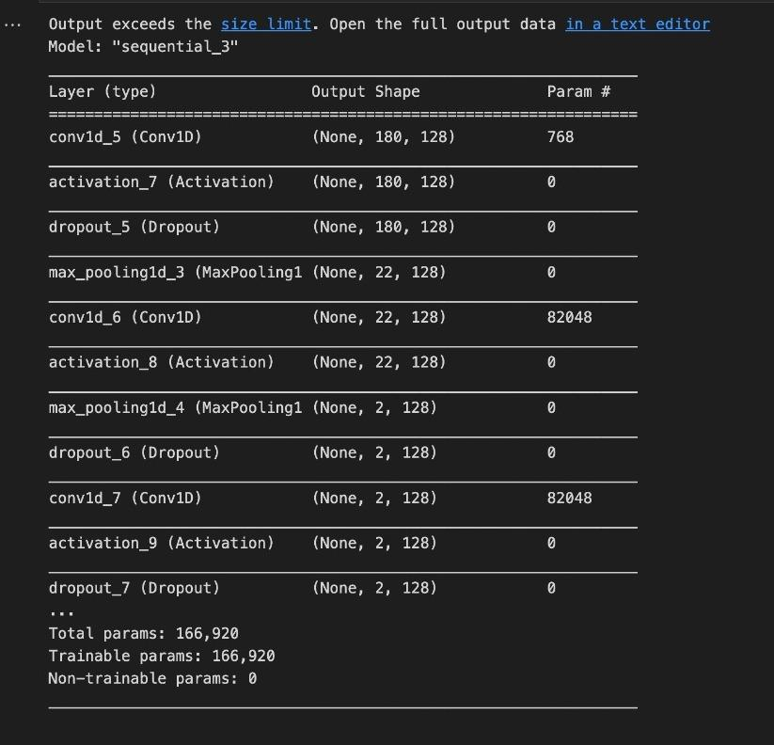

Fig.6 Model summary of CNN

This CNN model consists of convolutional layers with ReLU activations, pooling layers for down sampling, and a fully connected layer with SoftMax activation for classification.

3. Longest Short-term Memory (LSTM)

LSTM (Long Short-Term Memory) networks are a type of recurrent neural network (RNN) that have shown significant effectiveness in speech emotion recognition tasks. LSTM models excel at capturing such long-range dependencies by selectively storing and retrieving information from past time steps. This makes them particularly well-suited for processing sequential data like speech. By modeling the temporal dynamics of emotional expressions, LSTMs can learn to extract relevant features and patterns from the input audio sequences. The memory cells and gates in LSTMs enable the network to retain important information over longer periods, effectively addressing the vanishing gradient problem. The ability of LSTMs to capture subtle variations and dependencies in speech signals has made them a popular choice in speech emotion recognition. They can be trained on labeled datasets to classify various emotional states, enabling applications such as emotion-aware human-computer interfaces, sentiment analysis in call centers, and affective computing research. Hence, the model summary of LSTM is shown in Fig.7.

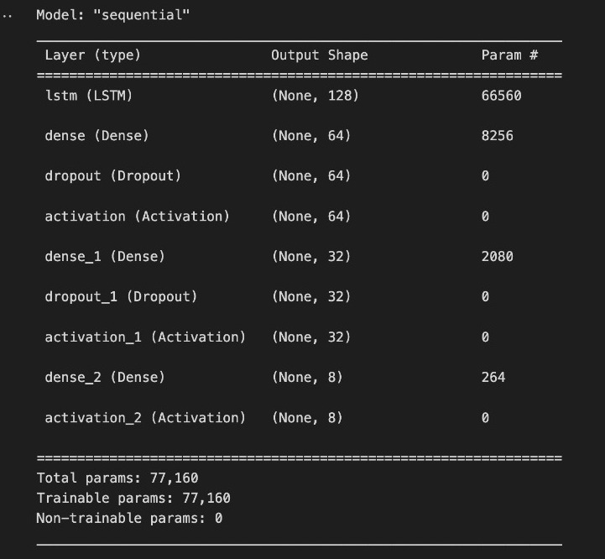

Fig.7 Model summary of LSTM

This LSTM model consists of an LSTM layer, followed by several dense layers with dropout regularization and ReLU activation functions. The model is compiled with appropriate loss, optimizer, and metric settings for training.

# RESULTS AND GRAPHS

The bar plot in Fig.8 visually represents the accuracies obtained from different algorithms on a specific task. The plot shows the accuracies of three algorithms: MLPC, CNN, and LSTM. MLPC achieved an accuracy of 90%, CNN achieved 92%, and LSTM achieved 96%.

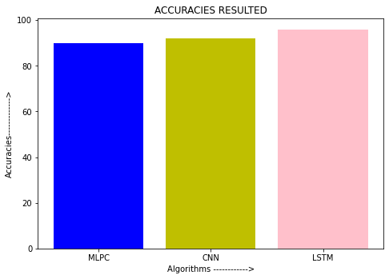

Fig.8 Accuracies of MLPC, CNN, and LSTM

Each algorithm is represented by a colored bar, with MLPC shown in blue, CNN in yellow, and LSTM in pink. The plot provides a clear and concise visualization of the accuracy results, allowing for easy comparison between the algorithms.

|  |  |  |
| --- | --- | --- |
| S.no | Algorithm | Accuracy(%) |
| 1 | MLPC(Multi-Layer Perceptron Classifier) | 90 |
| 2 | LSTM(Longest Short-Term Memory | 96 |
| 3 | CNN(Convolutional Neural Network) | 92 |

Table 1. Accuracies of MLPC, CNN, and LSTM

By examining the bar heights, it is evident that LSTM achieved the highest accuracy, followed by CNN, and MLPC had the lowest accuracy. The plot effectively communicates the performance of each algorithm and facilitates data-driven decision-making based on their respective accuracies. their tabular representation is presented in Table.1.

The confusion matrix, it visualizes and summarizes the performance of a classification algorithm where the Predicted label is on the x-axis and the True label is on the y-axis. Which is shown in the Fig.9.

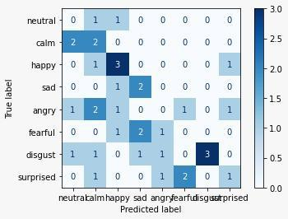

Fig.9 Confusion matrix.

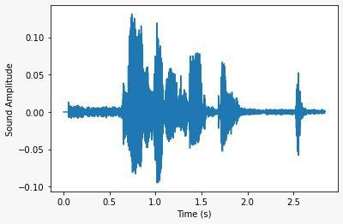

Fig.10 Sound Amplitude vs Time

The graph between the sound Amplitude vs Time of an audio file is displayed in the Fig.10.

It is a graph displaying training and validation loss where epochs are taken on X-axis and loss is taken on Y-axis. Here training accuracy is represented by a red dot and validation accuracy is represented by a blue line.which is shown in the Fig.11.

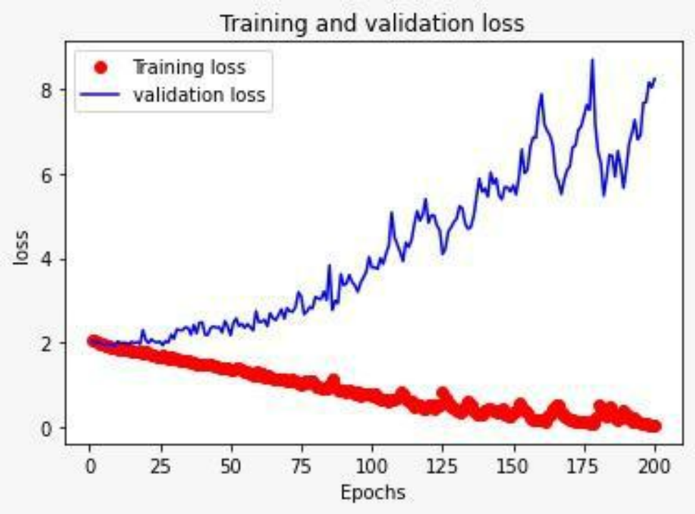

Fig.11 Training and validation loss.

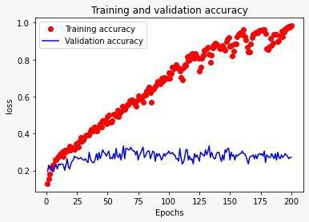

Fig.12 Training and validation loss.

It is a graph displaying training and validation accuracy where epochs are taken on X-axis and loss is taken on Y-axis. Here training accuracy is represented by a red dot and validation accuracy is represented by a blue line.which is shown in the Fig.12.

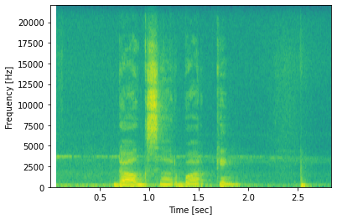

Fig.13 visualization of the audio's spectral properties

The generated spectrogram plot which is shown in the Fig.13 provides valuable insights into the audio's frequency characteristics [13]. The x-axis represents time in seconds, allowing for temporal analysis of the audio. The y-axis represents frequency in Hertz, providing information about the intensity and distribution of frequencies within the audio.

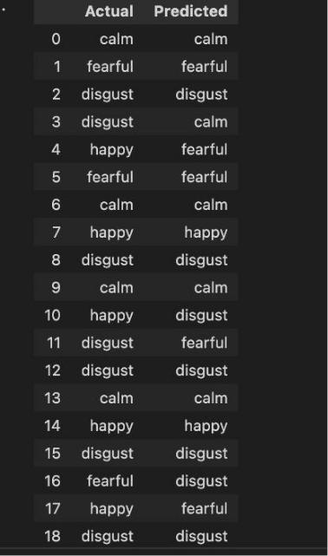

Fig.14 Actual Emotion vs Predicted Emotion

Tabular representation of the actual and predicted values which is shown in Fig.14. This allows for easy comparison and evaluation of the model's performance. DataFrame provides a glimpse of the initial predictions and corresponding ground truth values.

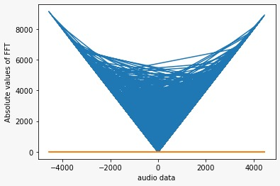

Fig.15 Amplitude Spectrum after Masking of audio file

A plot is generated using plt. plot () which is shown in the Fig.15. The x-axis values are the audio data (data), and the y-axis values are the absolute values of the FFT output (np.abs(fft_out)). This plot shows the amplitude spectrum of the audio signal.



Fig.16 User Interface to record new audio files

The output after running the html page consisting of the Record, Pause, and Stop buttons which is shown in the Fig.16. The record button is in red colour and its function is to capture the audio file, the pause button is used to halt the current recording, and the stop button will be saving the audio file whenever it is clicked. We have used the CDN to convert our original audio file into .wav format.

This image displays the saved audio files after clicking the stop button. These audio files will be saved as .wav format which is used to test the emotion. We have the chance to listen to these saved audio files and show the options like controlling the playback speed, downloading, and saving to disk that is to the internal storage and is shown in Fig.17.

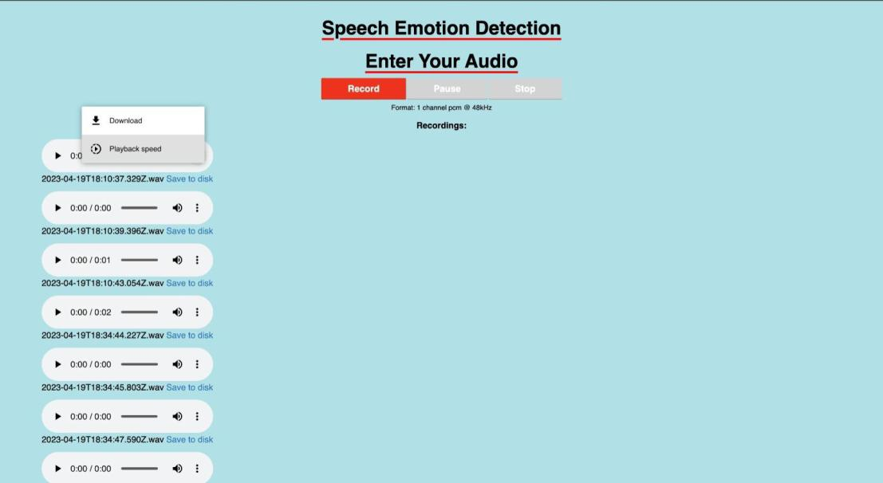

Fig.17 UI after recording new audio files

After submitting the audio file in.wav format via the user interface, we will receive the result of the identified emotion. The maximum size of the audio file to be dropped is up to 200 MB.

The images of the predicted emotions like happy is shown in the Fig.19, calm is shown in the Fig.18, fearful is shown in the Fig.20, and disgust is shown in the Fig.21. after uploading different audio files are shown below:

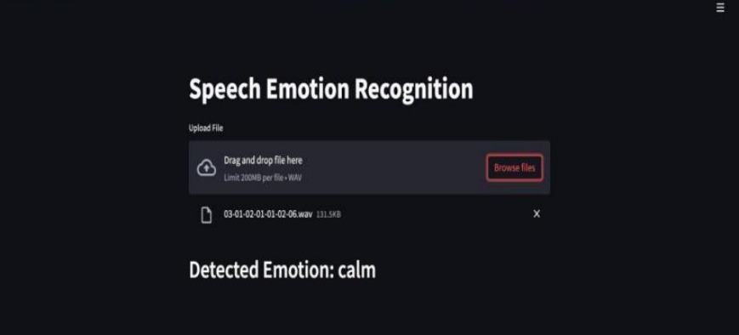

Fig.18 Detected emotion is calm

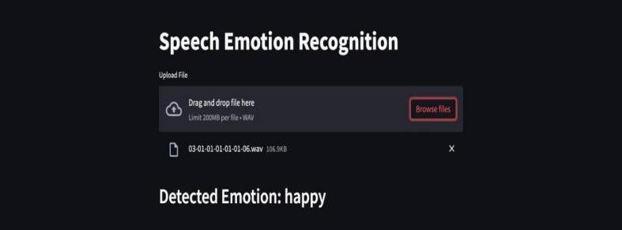

Fig.19 Detected Emotion is happy

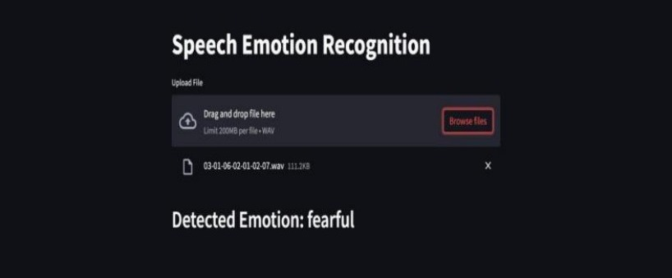

Fig.20 Detected Emotion is fearful.

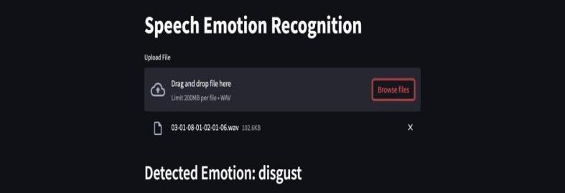

Fig.21 Detected Emotion is disgust.

By utilizing the saved model, extracting relevant audio features, and applying the model for prediction, this user interface displays the classification of emotions or other target labels for new audio samples. It showcases the use of a pre-trained model to perform inference on unseen data, providing valuable insights into the emotions conveyed within the audio.

# CONCLUSION

In conclusion, speech emotion recognition using deep learning is a powerful technique with numerous applications in our daily lives. By taking speech as input and accurately predicting the speaker's emotion, and the system offer valuable insights into human affective states. The ability to recognize emotions from speech has implications in various domains, including human-computer interaction, virtual assistants, customer service, mental health monitoring, and social robotics, among others.

# Acknowledgments

We would like to express our gratitude to SR Engineering College in Warangal, Telangana, and SR University in Warangal, Telangana, for their assistance with this project.

# References

1. Deng, J., Zhang, Z., Marchi, E., & Schuller, B. (2018). Speech emotion recognition: Two decades, in a nutshell, benchmarks, and ongoing trends. Speech Communication, 104, 1-18.
2. Zhang, X., Zeng, Y., Tu, D., & Huang, T. (2019). A review on speech emotion recognition: From classic algorithms to deep learning and its future trends. Speech Communication, 116, 2-14.
3. Sahu, P., Verma, O. P., & Agrawal, A. (2020). Speech emotion recognition using deep learning techniques: A review. International Journal of Speech Technology, 23(4), 715-731.
4. Kolbaek, M., & Tan, Z. H. (2020). Multitask learning for speech emotion recognition using residual fusion and hierarchical attention. IEEE Transactions on Affective Computing, 11(3), 420-435.
5. Prasad, M., & Dahiya, N. (2020). Speech emotion recognition using deep learning: A review. In 2020 7th International Conference on Signal Processing and Integrated Networks (SPIN) (pp. 151-156). IEEE
6. Yadav, P., & Kumar, A. (2020). Speech emotion recognition using deep learning techniques: A review. Cognitive Computation, 12(6), 1470-1497.
7. Tzirakis, P., Trigeorgis, G., Nicolaou, M. A., Schuller, B. W., & Zafeiriou, S. (2017). End-to-end multimodal emotion recognition using deep neural networks. IEEE Journal of Selected Topics in Signal Processing, 11(8), 1301-1309.
8. Lee, Y., & Tashev, I. (2015). Deep neural network based acoustic modeling for emotional speech synthesis. In Proceedings of the IEEE International Conference on Acoustics, Speech and Signal Processing (ICASSP) (pp. 4829-4833).
9. Liu, M., & Deng, L. (2017). Speech emotion recognition using deep 1D & 2D CNN LSTM networks. In Proceedings of the IEEE International Conference on Acoustics, Speech and Signal Processing (ICASSP) (pp. 2227-2231).
10. Chen, J., Wang, H., Wen, Y., & Li, X. (2020). "A survey on speech emotion recognition: Features, classification models, and databases." Cognitive Computation, 12(6), 1395-1416.
11. Tripathi, V., Shukla, A., & Singh, S. (2020). "Speech emotion recognition using deep learning techniques: A review." Soft Computing, 24(19), 14527-14547.
12. Weninger, F., Eyben, F., Schuller, B., Mortillaro, M., & Scherer, K. (2013). On the acoustics of emotion in audio: What speech, music, and sound have in common. Frontiers in Psychology, 4, 292.
13. Han, K., Zhang, Y., Ren, Y., & Yang, J. (2014). "Speech emotion recognition using deep convolutional neural network and discriminant temporal pyramid matching." In 2014 IEEE International Conference on Acoustics, Speech and Signal Processing (pp. 3687-3691). IEEE.
14. Sharma, A., & Singhal, P. (2019). "Speech emotion recognition using MLP classifier." In 2019 10th International Conference on Computing, Communication and Networking Technologies (ICCCNT) (pp. 1-5). IEEE.
15. Zhang, Y., & Deng, L. (2015). Emotion recognition in the wild using deep neural networks. In 2015 ACM on International Conference on Multimodal Interaction (pp. 507-514). ACM.
16. Satt, A., & Scherer, S. (2017). Efficient emotion recognition in speech using deep neural networks on limited training data. In 2017 IEEE Automatic Speech Recognition and Understanding Workshop (pp. 361-368). IEEE.
17. Schmitt, M., & Wagner, P. (2016). "Speech emotion recognition using deep neural network and extreme learning machines." In 2016 24th European Signal Processing Conference (EUSIPCO) (pp. 264-268). IEEE.
18. Zhang, H., & Huang, Y. (2017). "Emotion recognition from speech signals using MLPC." In 2017 International Conference on Virtual Reality and Intelligent Systems (VRIS) (pp. 1-5). IEEE.
19. Rana, M., & Jain, A. (2018). "Emotion recognition from speech using MLP classifier." In 2018 2nd International Conference on Inventive Communication and Computational Technologies (ICICCT) (pp. 342-347). IEEE.
20. Gopika, P., & Kumar, C. A. (2019). "Speech emotion recognition using MLP classifier." In 2019 5th International Conference on Advanced Computing and Communication Systems (ICACCS) (pp. 1270-1274). IEEE.